Kubernetes with Containers and DevOps Workshop

Hands-on lab step-by-step

Aralık 2018

## Create an Azure Kubernetes Service (AKS) cluster

Open your Bash Shell and login to your Azure subscription using the az cli

az login



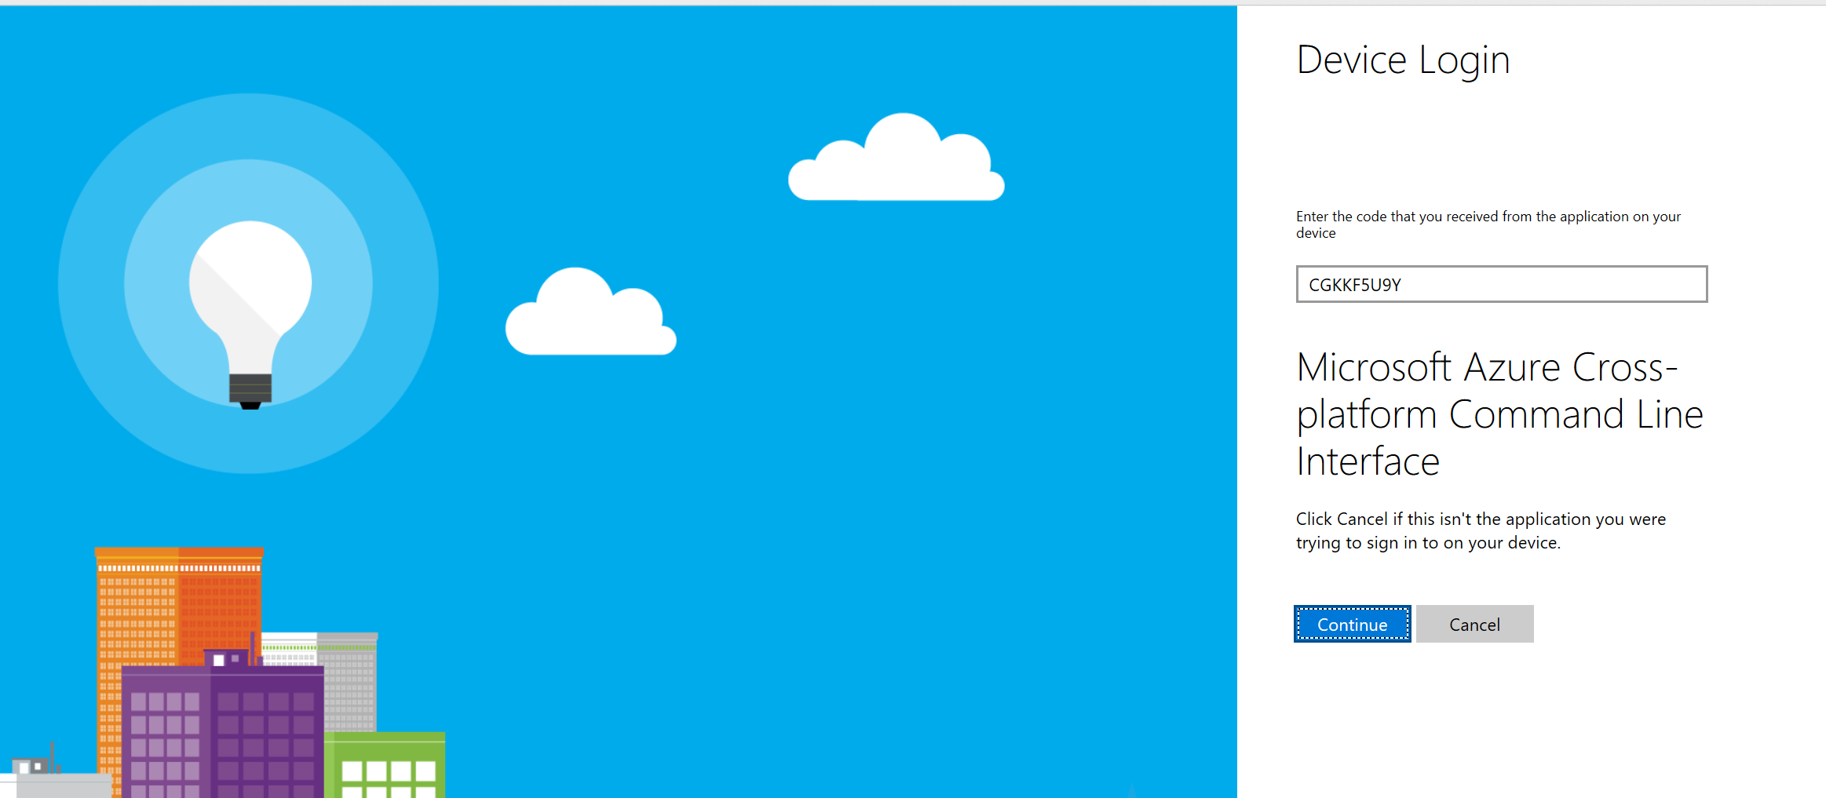

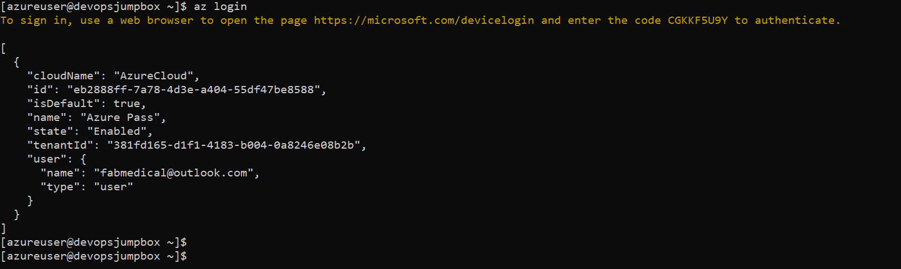

Verify your subscription is correctly selected as the default

az account list

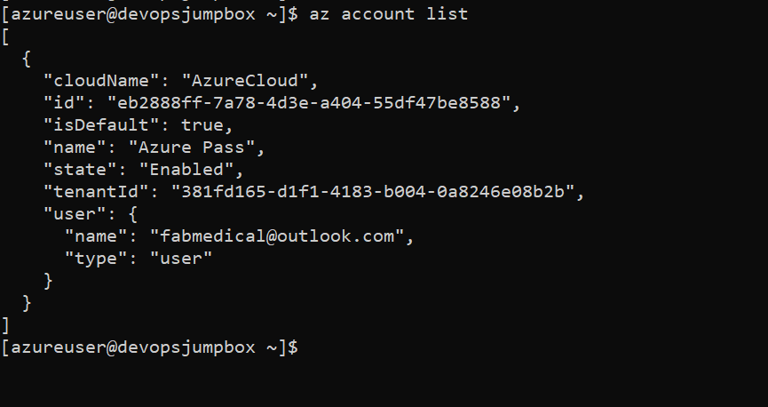

Find your RG name

az group list

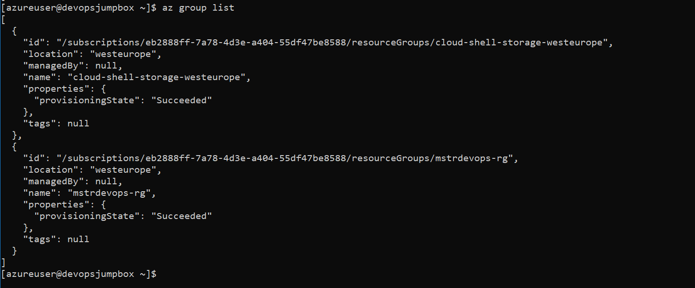

Create your AKS cluster in the resource group created above with 2 nodes, targeting Kubernetes version 1.8.6

az group create --name mstrdevopsaks-rg --location westeurope

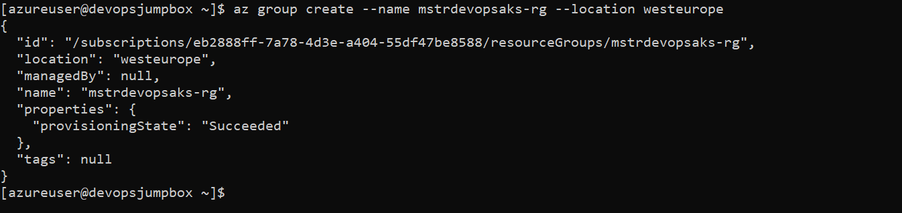

az aks create -n devopsaks -g mstrdevopsaks-rg -c 3 -k 1.11.4 --generate-ssh-keys



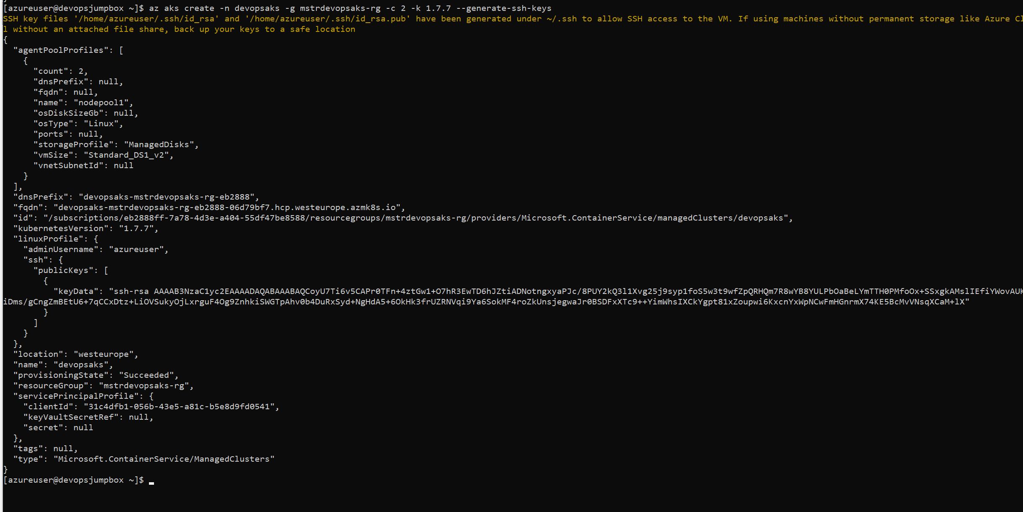

az aks list -o table



az aks get-credentials -n devopsaks -g mstrdevopsaks-rg



Verify you have API access to your new AKS cluster

kubectl get nodes

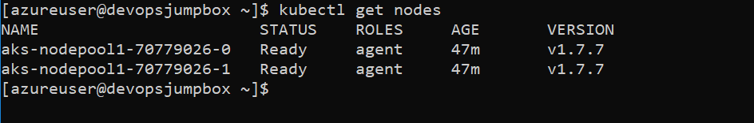

kubectl cluster-info

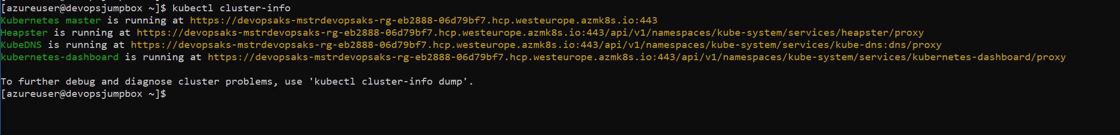

You should now have a Kubernetes cluster running with 2 nodes. You do not see the master servers for the cluster because these are managed by Microsoft. The Control Plane services which manage the Kubernetes cluster such as scheduling, API access, configuration data store and object controllers are all provided as services to the nodes.

kubectl get pods --all-namespaces

